Exercise 1: Data Types Detective
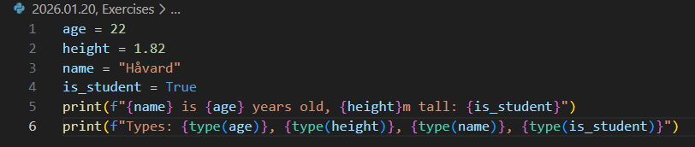
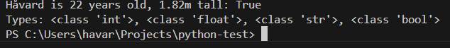
Other inputs
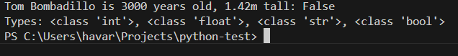
Can write numbers in str, but it will still be string:
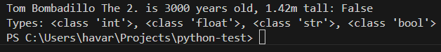
The types were int, float, str, and bool

Exercise 2: Type Converter
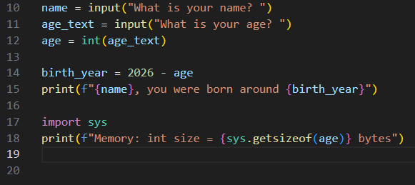

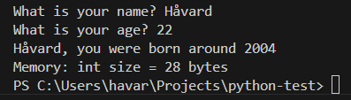

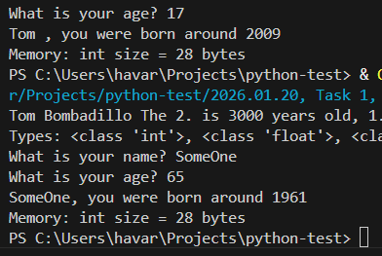

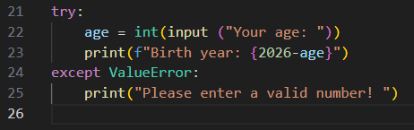
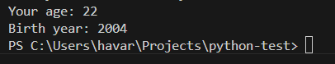
I was born in 2003, but haven’t had birthday this year, born in July
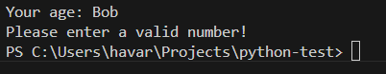

Exercise 3: Dynamic Typing
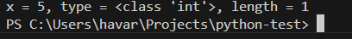

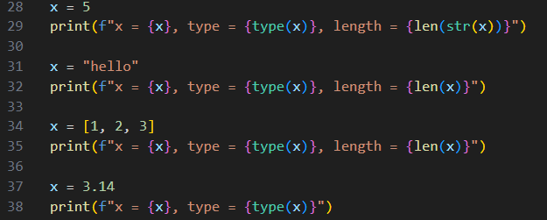

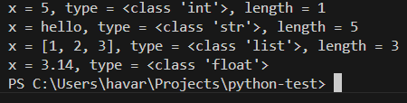

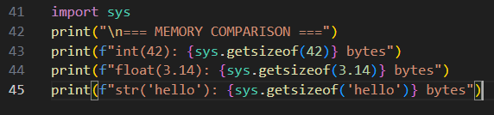

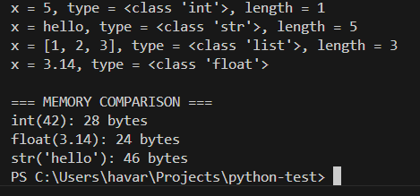

Exercise 4: Mini Calculator
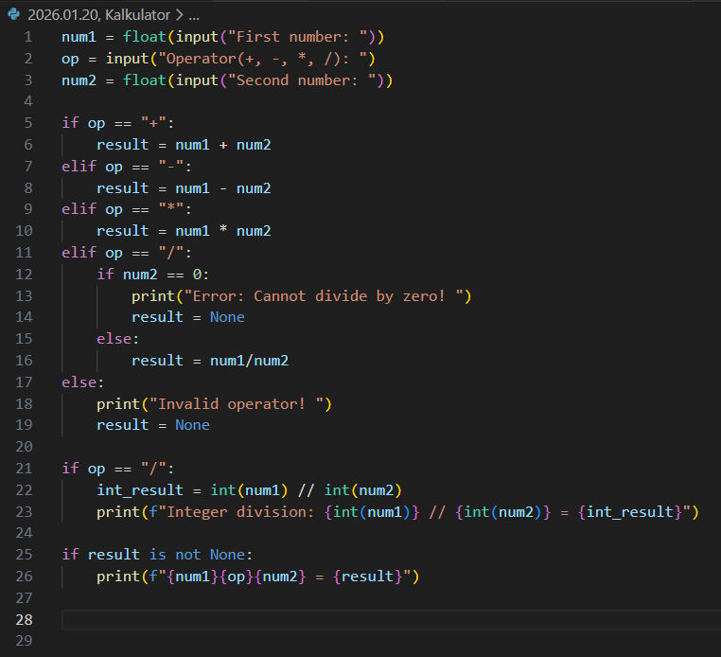

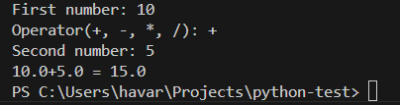
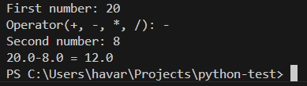

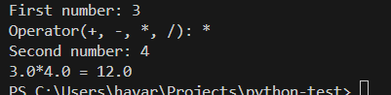

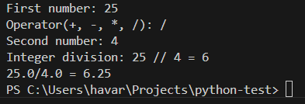

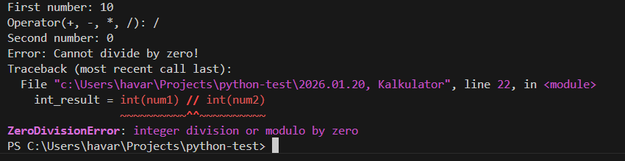

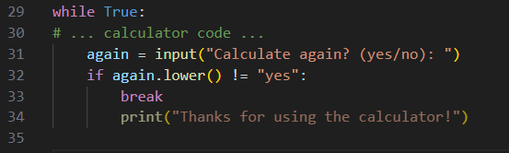

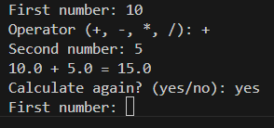
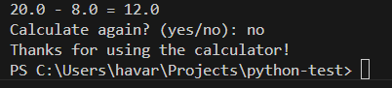

Questions after the exercises:
Which exercise was hardest? Why?
- The calculator exercise. I had to copy paste all the code over again when I added the while loop to have the right syntax

Which concept surprised you? (Dynamic typing? Memory sizes?)
- Memory of float, since it lower than normal integer, though it includes a decimal

